IN DAY 1 I LEARNED HOW TO CREATE THE AWS CLOUD CONSOLE MANAGEMENT ACCOUNT.

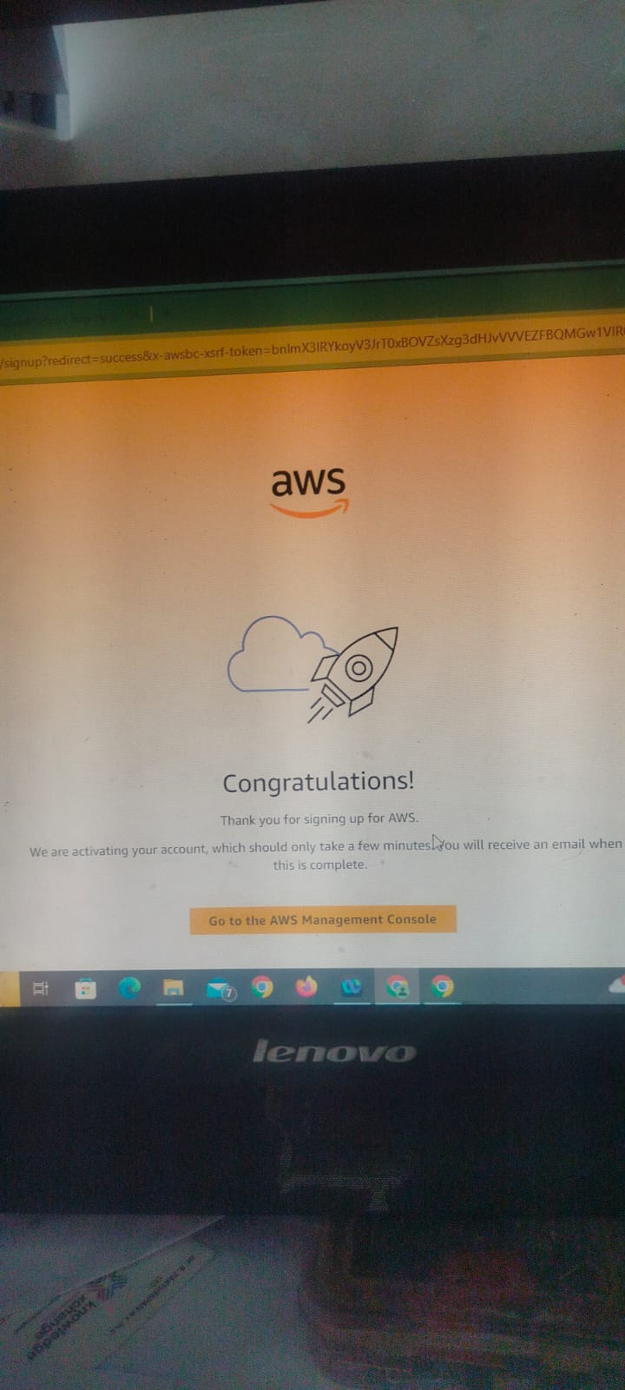

In DAY 2 I HAVE LEARNED HOW TO LAUNCH THE EC2 INSTANCE AND ASLO HOW TO CONNECT THE REMOTE DESKTOP USING EC2 SERVICE.

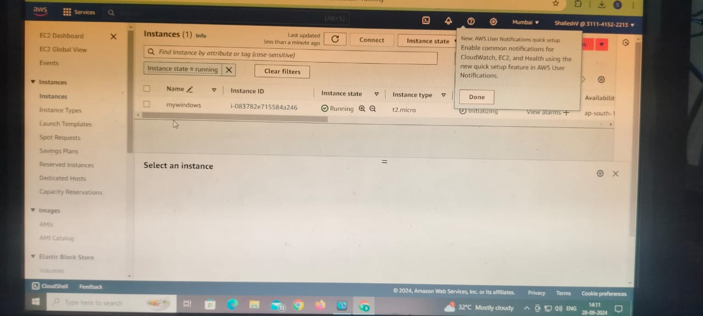

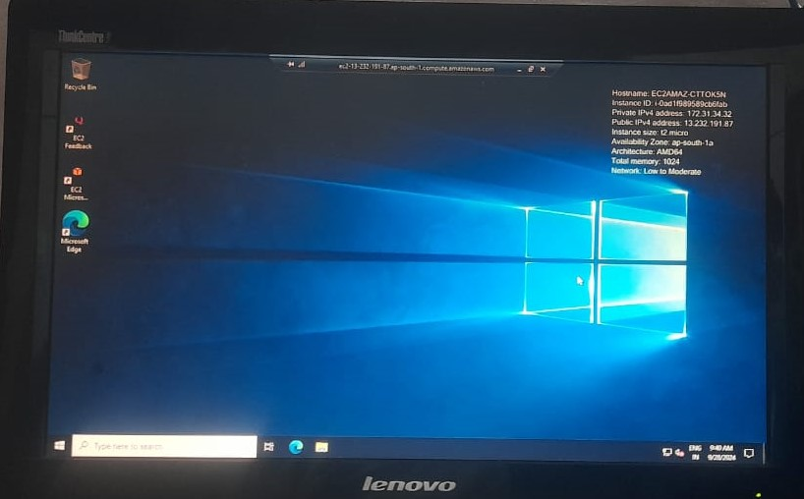

IN DAY 3 I HAVE LEARNED HOW TO CONNECT THE LINUX MACHINE USING EC2 SERVICE AND ASO HOW TO CREATE WEBSERVER IN LINUX MACHINE.

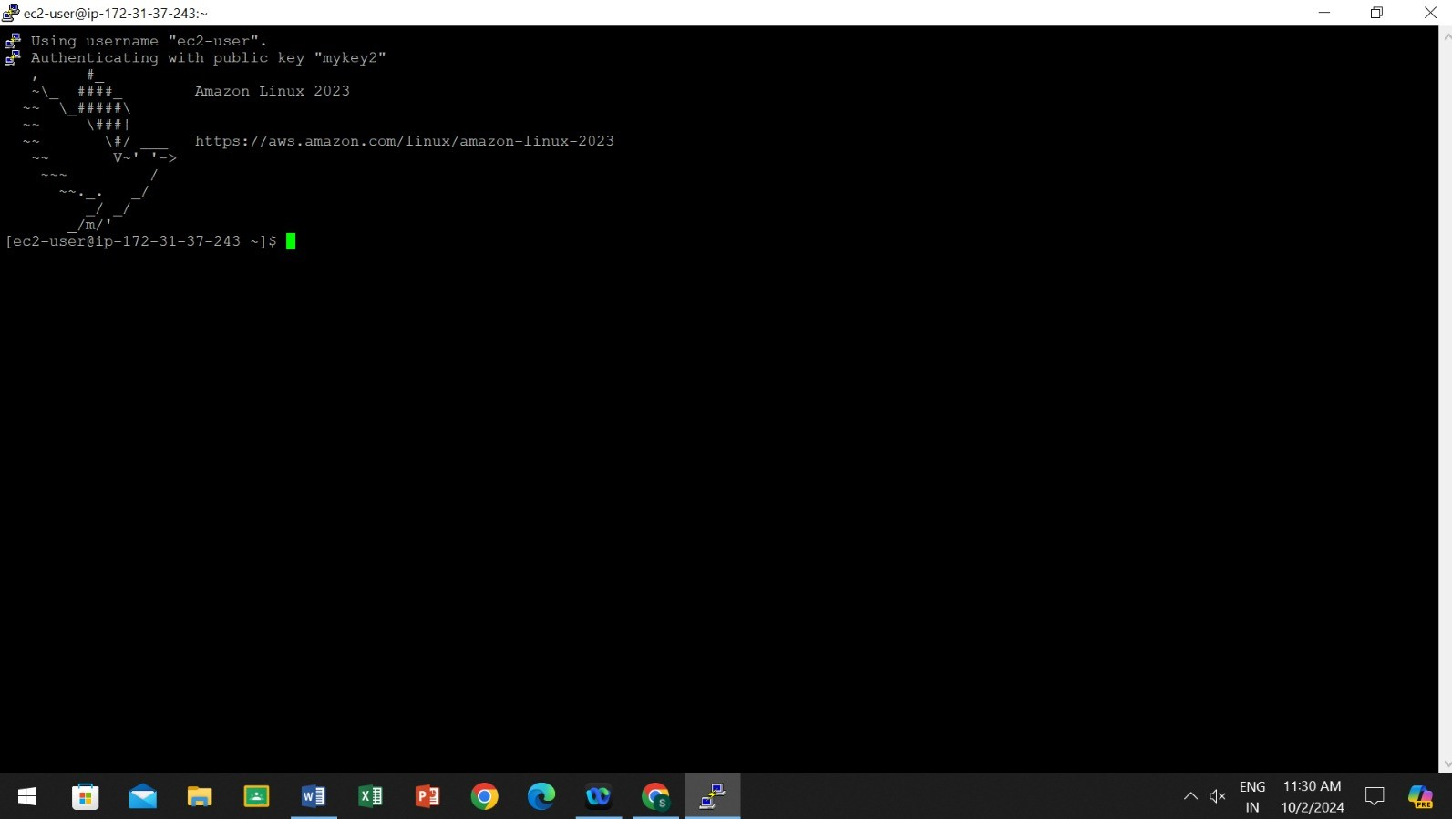

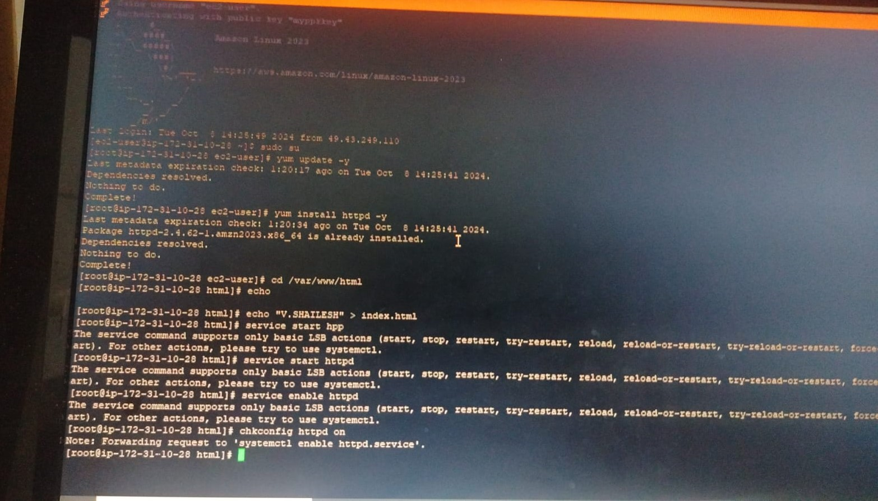

IN DAY 4 I HAVE LEARNED HOW TO CREATE THE IAM SERVICE AND ALSO HOW TO CREATE BUCKET AND UPLOAD THE IMAGE IN S3.

IN IAM THERE ARE SEVERAL KEYWORDS SUCH AS USER GROUPS, ROLES AND POLICIES.

